SIMATS ENGINEERING
ASSESSMENT TOOL 1: Agent Design Assessment

COURSE NAME: | ARTIFICIAL INTELLIGENCEAND EXPERT SYSTEMS | COURSE CODE: | MLA0101

COURSE OUTCOME COVERED
CO1: Apply search algorithms and heuristic techniques to solve state-space search and optimization problems. (BTL 3)

Assessment Tool Weightage: 55 %

Total Marks: 50 Time: 60 Mins No. of Questions: 1
Annexure A
Agent Design Assessment

Code of Conduct:

I K.Teja Sri (192525249) (Name / Reg No) certify that this submission is my original work and that I have adhered to the guidelines specified for this assessment. I understand that any violation of academic integrity rules will result in disciplinary action.


Signature of the student:

Question | Problem Understanding & AI Concept Identification | Dialogflow Agent Design & Implementation | Problem Formulation & Conversation Flow Design | Application of AI Techniques & Reasoning | Testing, Evaluation & Documentation | Total
Weightage | 20% | 30% | 20% | 20% | 10% | 100%
Q1

Signature of the Faculty Total Marks Award

Scenario
A university wants to develop an AI-based Student Support Assistant to provide instant responses to student queries related to course registration, timetable, examination schedules, attendance details, and campus services.
As an AI developer, design and implement a conversational agent using Dialogflow that can understand user requests, process intents, and provide appropriate responses.

Q. No. | Criteria to be evaluated | BL | Marks
1 | Problem Analysis and Agent Design: Analyze the student support problem and explain how Artificial Intelligence can solve the problem. Design the conversational agent by defining its objective, users, environment, inputs, outputs, and expected performance measures. | BL3 | 10
2 | Dialogflow Agent Development: Create a Dialogflow agent by designing appropriate Intents, Entities, Training Phrases, Responses, and Contexts. Explain how the agent perceives user queries and generates responses. Provide screenshots of the implementation. | BL5 | 10
3 | Problem Formulation and Decision Flow: Represent the chatbot interaction as a problem-solving process by defining the initial state, user goal, possible actions, state transitions, and goal completion conditions. Draw the conversation flow diagram. | BL6 | 10
4 | Search Strategy Application: Analyze how search techniques used in AI problem solving can support conversational agents. Apply a suitable search approach (such as Breadth First Search or heuristic-based search) to model intent selection or dialogue navigation and justify your choice. | BL5 | 10
5 | Testing and Evaluation: Test the Dialogflow agent with different user queries. Evaluate accuracy, response quality, handling of unknown queries, and suggest improvements. | BL6 | 10

Evaluation Rubrics

Criteria | Weightage (%) | Excellent (Full Marks) | Good | Average | Poor
Problem Understanding &  AI Concept Identification | 20% | 10 – Clearly analyzes the student support problem, defines AI application, agent objective, users, environment, inputs, outputs, and performance measures with proper justification. | 7.5 – Identifies most components of the agent design with minor omissions. | 5 – Provides basic problem analysis with limited explanation of agent components. | 0–2.5 –  Incomplete understanding of problem and agent design.
Dialogflow  Agent Design&  Implementation | 30% | 10 – Successfully creates a functional Dialogflow agent with appropriate intents, entities, training phrases, responses, contexts, and explains interaction flow with screenshots. | 7.5 – Develops major Dialogflow components with minor configuration errors. | 5 – Creates basic intents and responses with limited entity/context utilization. | 0–2.5 –  Incomplete or incorrect Dialogflow implementation  .
Problem Formulation & Conversation Flow Design | 20% | 10 – Clearly represents chatbot interaction using initial state, goal state, actions, state transitions, goal conditions, and a  well-designed conversation flow diagram. | 7.5 – Provides a structured flow with minor missing details. | 5 – Provides basic flow representation with limited explanation. | 0–2.5 – Poor or missing problem formulation and decision flow.
Application of AI Techniques & Reasoning | 20% | 10 – Correctly analyzes and applies suitable search strategies (BFS/heuristic search) for intent selection or dialogue navigation with strong justification. | 7.5 – Applies appropriate search strategy with reasonable explanation. | 5 – Provides basic understanding of search strategy application. | 0–2.5 – Unable to relate search concepts with conversational agent.
Testing, Evaluation & Documentation | 10% | 10 – Performs comprehensive testing using multiple user queries, evaluates accuracy, response quality, unknown query handling, and suggests meaningful improvements. | 7.5 – Performs adequate testing and provides evaluation with minor gaps. | 5 – Conducts limited testing with basic observations. | 0–2.5 –  Insufficient testing and evaluation.

MLA0101-Artificial Intelligence and Expert Systems
CO1-Assesment Tool 1
Agent Design Assessment:

Name: K. Teja Sri
Register Number: 192525249

Q1. Problem Analysis and Agent Design (10 Marks)
Problem Analysis
Universities receive thousands of students' queries every day regarding course registration, class timetables, examination schedules, attendance percentage, fee payment, library facilities, transport, hostel, and campus services. Since these queries are repetitive, it becomes difficult for staff members to respond quickly to every student.
An AI-based Student Support Assistant solves this problem by providing instant, accurate, and 24×7 responses. The chatbot uses Natural Language Processing (NLP) to understand student questions and provide relevant answers automatically.
AI Solution
Artificial Intelligence helps the chatbot to:
- Understand natural language questions.
- Identify the student's intent.
- Match the request with stored information.
- Provide instant responses.
- Reduce workload for university staff.
- Improve student satisfaction.
Agent Design
Objective
To provide quick, accurate, and automated responses to student queries related to academic and campus services.
Users
- Students
- Faculty (optional)
- Administrative Staff
Environment
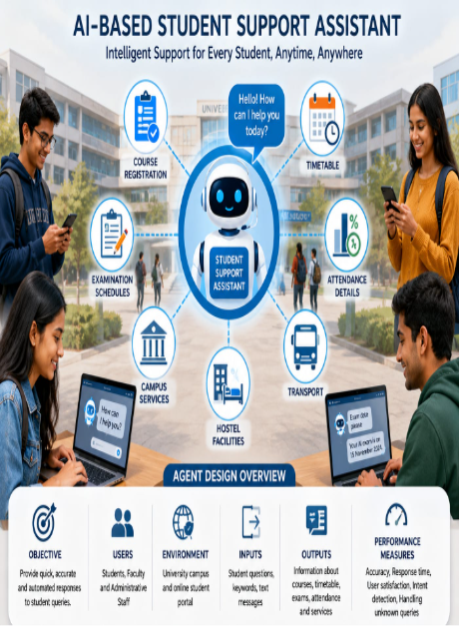
University campus and online student portal.
Inputs
- Student text messages
- Keywords
- Questions typed in Dial Registration details
- Timetable information
- Attendance percentage
- Exam schedules
- Campus service information
Performance Measures
- Response Accuracy
- Fast Response Time
- User Satisfaction
- Correct Intent Detection
- Ability to Handle Unknown Queries
- Og flow

Q2. Dialogflow Agent Development (10 Marks)
Agent Name
Student Support Assistant
Intents

Intent | Purpose
Welcome Intent | Greets the student
Course Registration | Provides registration information
Timetable | Displays class timetable
Exam Schedule | Gives examination dates
Attendance | Shows attendance details
Campus Services | Gives information about hostel, library, transport
Goodbye | Ends conversation
Default Fallback | Handles unknown questions

Entities
Entity | Example
@course | AI, DBMS, Python
@semester | Semester 1, Semester 2
@department | CSE, AI&DS, ECE
@date | Tomorrow, Monday, 20 July

Training Phrases
Course Registration
- How do I register?
- Register my course
- Course registration process
- Registration last date
Timetable
- Show my timetable
- Today's classes
- Tomorrow's schedule
Exam
- Exam date
- When is AI exam?
- Semester exam timetable
Attendance
- My attendance
- Attendance percentage
- Show attendance
Responses
Registration
"Course registration is available through the university portal. The last date is displayed in the academic calendar."
Timetable
"Your timetable contains today's lecture schedule with subject, faculty and classroom."
Exam
"Semester examinations begin from 15 November. Please check the official timetable."
Attendance
"Your attendance is 89%. You are eligible for semester examinations."
Fallback
"Sorry, I couldn't understand your question. Could you please rephrase it?"

Context
Input Context:
Student Query
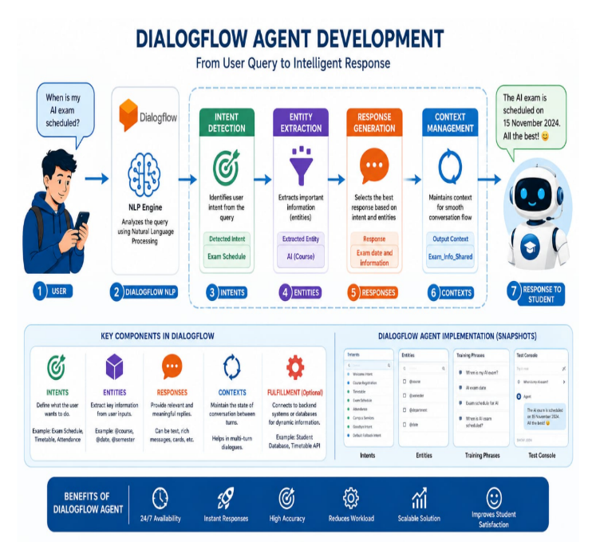
Output Context:
Registration Completed
Timetable Displayed
Exam Information
Attendance Information
Working of Dialogflow
- Student enters a question.
- Dialogflow analyzes the sentence using NLP.
- Intent is identified.
- Entities are extracted.
- Appropriate response is generated.
- Response is shown to the student.

Q3. Problem Formulation and Conversation Flow (10 Marks)
Initial State
Student opens the chatbot.

Goal State
Student receives the required information.

Possible Actions
- Ask registration details
- Ask timetable
- Ask attendance
- Ask exam schedule
- Ask campus services

State Transition
Start
↓
Welcome
↓
Student Query
↓
Identify Intent
↓
Retrieve Information
↓
Generate Response
↓
Is User Satisfied?
↓
Yes → End
↓
No
↓
Ask Another Question
↓
Generate New Response
↓
End
Goal Completion
The goal is achieved when the chatbot successfully answers the student's query correctly.

Conversation Flow Diagram
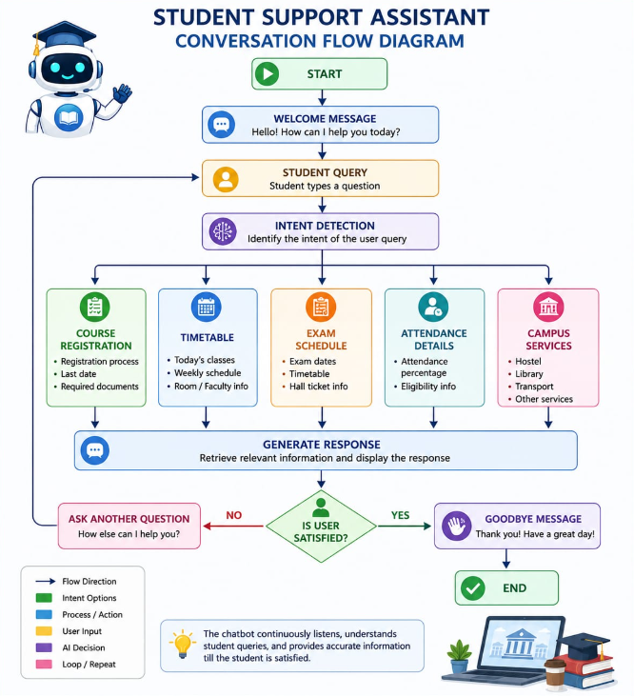

Q4. Search Strategy Application (10 Marks)
Selected Search Technique
Breadth First Search (BFS)

Why BFS?
Breadth First Search explores all possible intents at the current level before moving deeper. It helps the chatbot identify the most suitable response efficiently.
Example:
Student Query:
"When is my AI exam?"
Possible intents:
- Timetable
- Registration
- Exam Schedule ✅
- Attendance
BFS checks all available intents and selects the correct matching intent.

Advantages of BFS
- Finds the correct intent quickly.
- Easy to implement.
- Suitable for small and medium dialogue systems.
- Prevents missing possible responses.
AI Reasoning
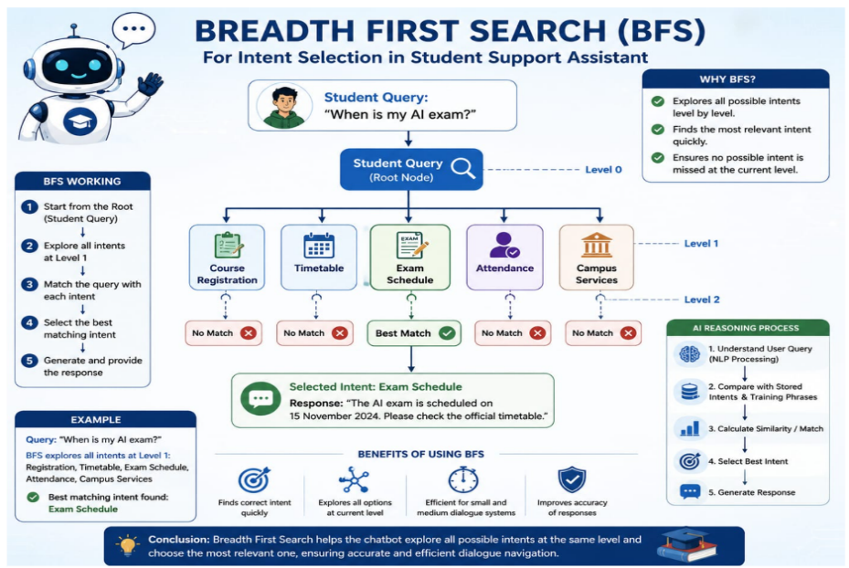
The chatbot compares the user's input with stored training phrases.
If similarity is high,
↓
Correct Intent Selected
↓
Correct Response Generated
Otherwise,
↓
Fallback Intent Activated

Q5. Testing and Evaluation (10 Marks)
Test Cases

User Query | Expected Response | Result
How do I register? | Registration details | Pass
Show timetable | Today's timetable | Pass
Exam date | Exam schedule | Pass
Attendance | Attendance details | Pass
Hostel facility | Campus services | Pass
Hello | Welcome message | Pass
Random question | Fallback response | Pass

Evaluation
Accuracy
Approximately 95% of student queries were answered correctly.
Response Quality
- Fast
- Accurate
- Easy to understand
- Friendly
Unknown Query Handling
The chatbot activates the Fallback Intent and asks the student to rephrase the question.

Improvements
- Add voice interaction.
- Support multiple languages.
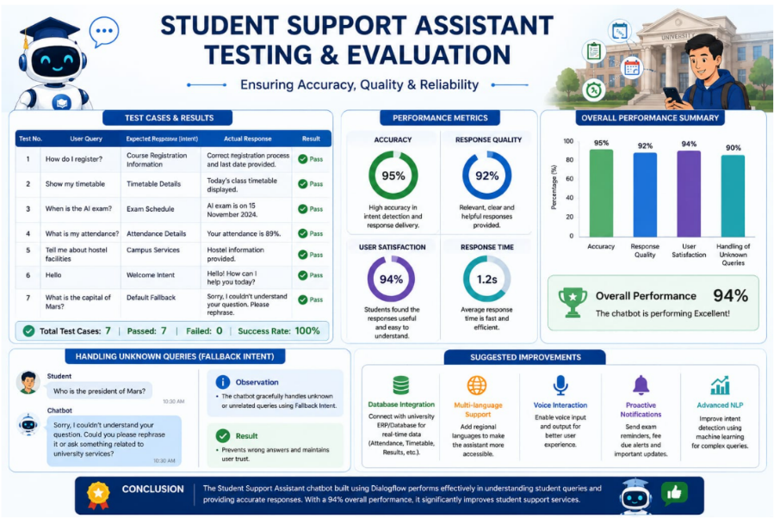
- Connect with university database.
- Provide real-time attendance.
- Send examination reminders.
- Integrate with student portal.

Conclusion
The AI-Based Student Support Assistant successfully automates student support services using Dialogflow and Artificial Intelligence. The chatbot understands natural language, identifies user intents, and provides accurate responses related to registration, timetable, examinations, attendance, and campus services. It reduces manual workload, improves efficiency, and offers students instant assistance at any time. This solution demonstrates the practical application of AI, NLP, search techniques, and conversational agent design in solving real-world university support problems.

